**Note 1:**

1. This product does not support updating the official Klipper, Moonraker, fluidd and other servers, otherwise the machine will not work properly. If you consider installing more official Klipper plug-ins on your own, expanding more functions, learning the underlying logic of the software, before that, it is recommended that you get your own EMMC ADAPTER in order to avoid reinstallation of the system image to restore the machine when an error occurs.[Image installation method:](#_Neptune4&4Pro Mirror Installation Method)
2. If you encounter a situation where your machine does not start properly, please try to troubleshoot the problem according to the FAQ.

## File Description

### **Touch Screen Firmware**

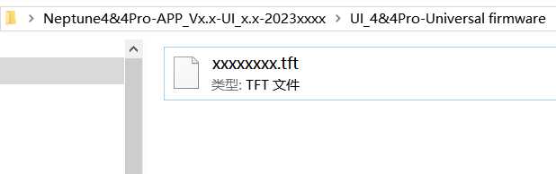

**The ".tft" suffix file is the touch screen firmware file:** To upgrade the touch screen firmware, you need to use a TF card. Copy the file to the root directory of the TF card, then insert the TF card into the internal card slot of the touch screen, and re-power on to update. [Please refer to the following for detailed steps.](#_Touch Screen Firmware Update)

### **Main Control Software and Machine Configuration Files**

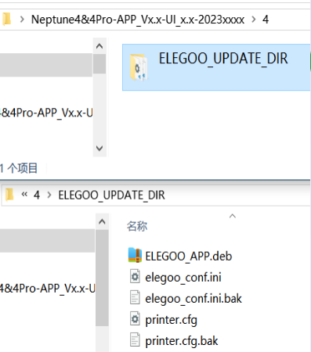

**"ELEGOO_UPDATE_DIR" folder:**

This is the folder where the main control software and machine configuration files are stored, and it is an important folder for upgrading the main control. Please select the corresponding upgrade folder according to your machine model. [For detailed upgrade steps, please refer to the following.](#_Master Control Software Update) It includes a software upgrade package, and a machine basic configuration file, described as follows.

## 

## Master Control Software Update

**Preparation: Copy the【Upgrade Folder】to the root directory of the U disk.**

Insert the U disk that comes with the machine into the computer, and copy the "ELEGOO_UPDATE_DIR" folder of the corresponding machine to the root directory of the U disk.

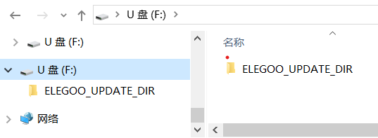

**Update method 1: Upgrade by using the touch screen control**

When the machine is turned on normally, insert the U disk with the 【Upgrade Folder】into the USB port of the printer panel (Diagram 1-1), and wait for the U disk to be read successfully (Diagram 1-2, on the page of selecting files to print, check whether the file and folder information of the U disk can be read. If so, the U disk is mounted successfully.), then click【Settings】→【Information】on the main interface, click the upgrade button arrow on the information page (Diagram 1-3), and click confirm follow the prompt steps, and then upgrade the software. After the upgrade is successful, the machine will automatically restart. After machine restarting, please check whether the firmware version number has changed.

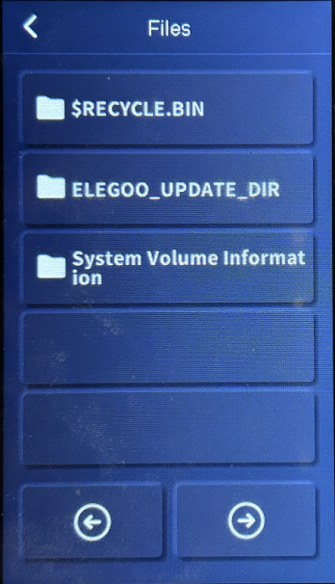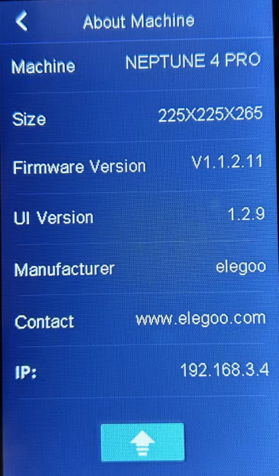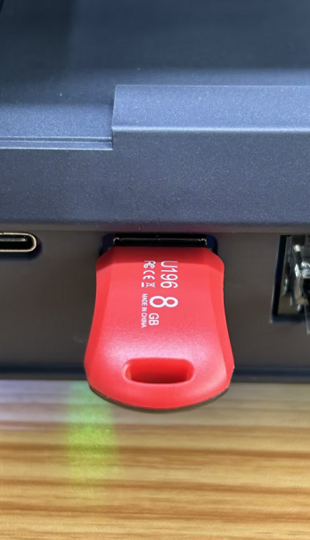

**1-1**

**1-3**

**1-2**

**If an error message is displayed, please follow the instructions below to check:**

① Check whether the U disk file is normal, use a computer to check whether the "ELEGOO_UPDATE_DIR" folder in the U disk contains the upgrade software package and machine configuration files.

② Check whether the U disk is read normally, and perform the operation again according to the steps.

③ Re-insert and unplug the U disk or replace the U disk, and perform the operation again.

④Restart the machine and try again. If it cannot be restarted, please troubleshoot the problem according to FAQ-2.

## Touch Screen Firmware Update

### **Kind Reminder：**When the machine is normally used, it is recommended to update the main control software first, and then update the touch screen firmware. If the firmware version of the touch screen is the same as that of your machine, there is no need to update it again.

**Update steps:**

1. Format the TF card. (To upgrade the touch screen firmware, you need to format the TF card as required)

Get the given away random TF card and format it as:

File system (F): FAT32, Allocation unit size (A): 4096 bytes

1. Copy the touch screen firmware file under the "UI_4&4Pro-Universal firmware" folder to the root directory of the TF card, as shown in the diagram.

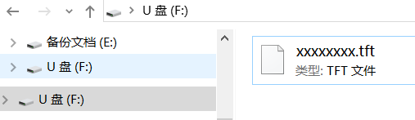

1. Loosen the screws and remove the rear cover of the screen; pay attention to the direction of the card insertion and insert the TF card.

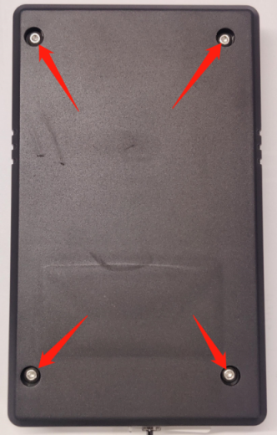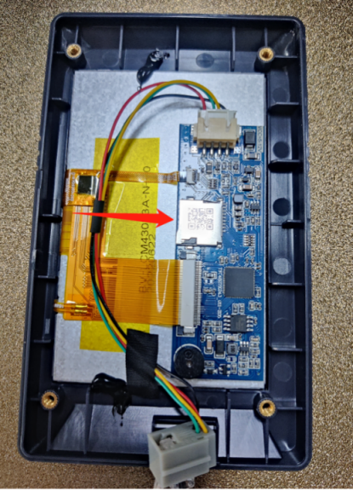

4. Unplug the touch screen plug (or restart the power supply), and wait until the firmware is loaded. The firmware loading process and the completed interface display are shown in the diagram. After the loading is completed, the TF card must be removed first and then restart the machine. (Time required for touch screen firmware update: about 90 seconds)

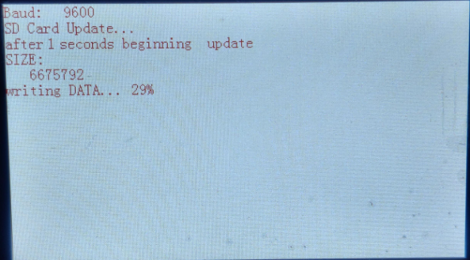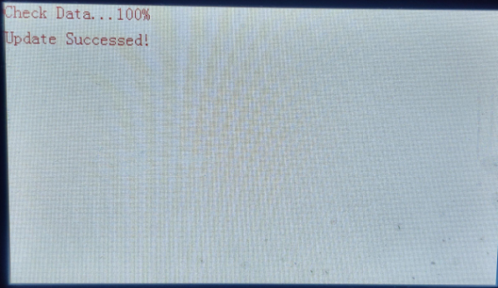

## FAQ:

**1. What is the root directory?**

After inserting the U disk/memory card, the first interface of the U disk/memory card.

**2. After restarting the machine, it is always displayed on the boot interface and cannot be started normally?**

The main reason: the interval between shutdown and startup is too short, and the motherboard is not completely shut down. Solution: turn off the power, wait for 30 seconds, and turn on the power again.

**Possible causes:**

* You have modified the system files or machine configuration files by yourself. It may be that some incorrect modifications lead to the failure to start normally. In this case, you need to use the serial port terminal to upgrade the Linux background.
* It is also possible that the cable connector of the touch screen is not in good contact. It is recommended to plug the touch screen tightly and then restart the machine.

**3. Do I need to re-level after updating software or UI firmware (touch screen firmware)?**

After reloading the main control software and the default configuration of the machine, the leveling data will be cleared, and it is necessary to re-level the build platform and set Z compensation. Updating the UI firmware does not affect the leveling data.

**4. At the beginning of printing, the machine does not respond to control fan, light, heating and other actions?**

After selecting the print file and starting to print, the machine usually heats the hot bed and the hot end first, and the control buttons will not respond during the waiting heating stage. This is the setting of the klipper system process. It is a normal phenomenon that other operations are prohibited during heating. Waiting for heating completed, it can be controlled normally.

**5. During the printing process, when controlling the light switch, the light response on the machine is delayed. Is this normal?**

Normal. During printing, light control or other operations will be queued in the klipper control process first, and it is normal for some delay in the response.

**6. Update/change log?**

Please refer to the change log for details.

**7. Can't maneuver on the display to update the firmware?**

Please use one of the following methods to update/repair the firmware:

① Fix the firmware

② Use the serial terminal to enter the system background upgrade

③ Installing the Operating System

### Update method 2: Use the serial port terminal to perform the Linux background upgrade

**Note:** This upgrade method applies to the situation where the screen cannot run and cannot enter the upgrade interface from the screen.

The operation is relatively complicated, and you need to prepare a Type-C data cable. You are advised to troubleshoot problems according to FAQ-2 before using this method. The method steps are as follows:

Steps are as below：

1. Download and install the serial communication software putty. URL：<https://putty.org/>

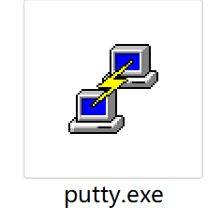

1. Download and install the ch340 driver. URL：<https://sparks.gogo.co.nz/ch340.html>
2. Connect the Type-C port of the communication panel of the printer with a Type-C cable, and connect the other port to the computer USB.
3. Check the corresponding COM port in the computer device manager.

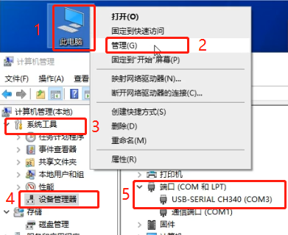

(5) After opening putty, select the serial port mode to connect, and click Open.

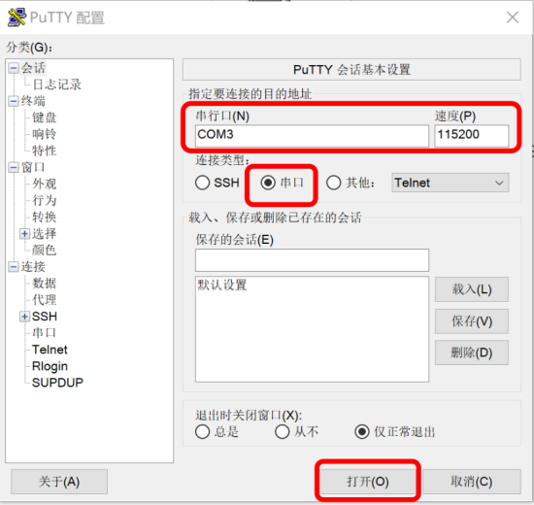

(6) After clicking Enter several times, you will be prompted to log in, enter the user name and password, user name: mks, and password: makerbase. (The entered password is not visible, just click Enter after normal input)

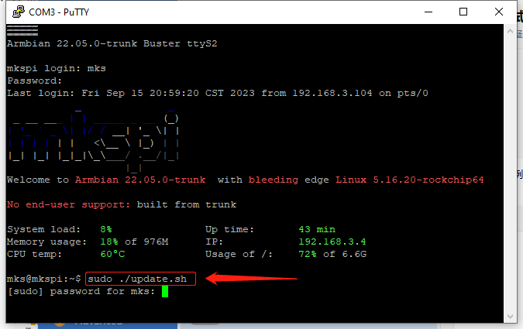

1. Insert the upgrade U disk with prepared files and folders into the USB port of the printer.

Run the upgrade script and enter the command. Enter the command "sudo + space + . /update.sh", as shown below, there must be a space character, otherwise it will feedback ~bash:sudo . /update.sh: No such file or directory.

sudo ./update.sh

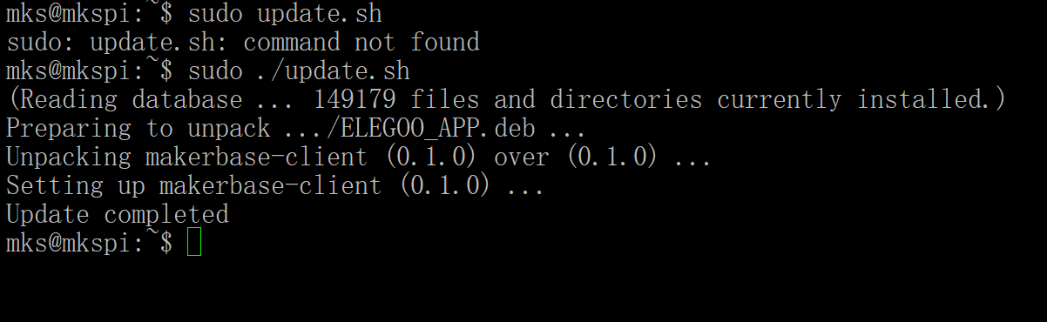

Note the space here

When prompted for a password, enter the password "makerbase" and press enter.

(8) Wait for the upgrade to complete. The upgrade completion status is shown as below.

(9) Just restart the machine after 30 seconds of power failure.

## Neptune4&4Pro Image Installation Method

**Prepare the tools:**

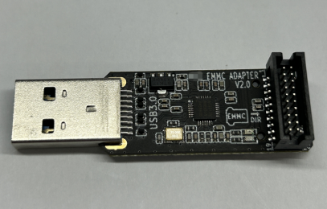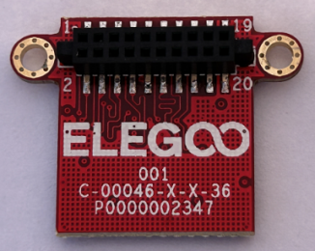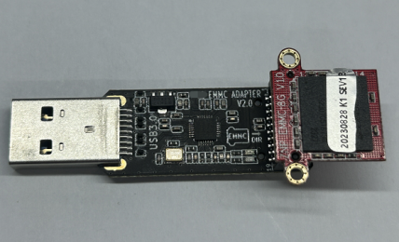

EMMC ADAPTER (Self-purchase)  
Remove the EMMC module from the motherboard

[Raspberry Pi Imager](https://www.raspberrypi.com/software/)：<https://www.raspberrypi.com/software/>

Image Download Site：(Do not provide a link, please contact technical support to obtain!)

GitHub：

Baidu Pan:

**1. Image installation steps:**

① Install the [Raspberry Pi](https://www.raspberrypi.com/software/) [Imager](https://www.raspberrypi.com/software/)

② Decompress the downloaded Image compressed package, get the system Image file with .img suffix.

③ Connect the EMMC module to the computer and make sure it can be read normally.

③ Connect the EMMC module to the computer and make sure it can be read normally.

④ Open the installed [Raspberry Pi Imager](https://www.raspberrypi.com/software/).

⑤ Click [CHOOSE OS], select [Use custom], and choose the system Image file.

⑥ Click [CHOOSE STORAGE], and select the USB storage device you just inserted

⑦ Click [WRITE]

⑧ Wait for the writing and verification is complete.

Tip: After the completion of the verification may prompt the error in the figure, or prompt the formatting of the disk is normal, remove the EMMC module can be. Note that there are steps below.

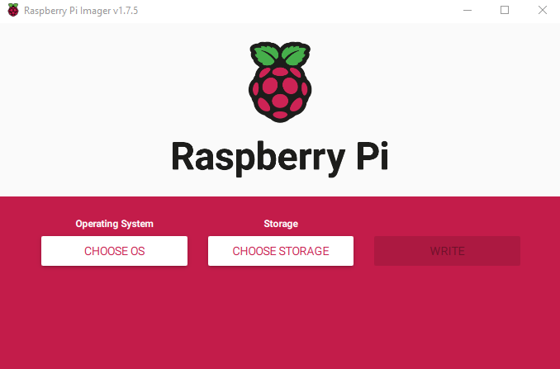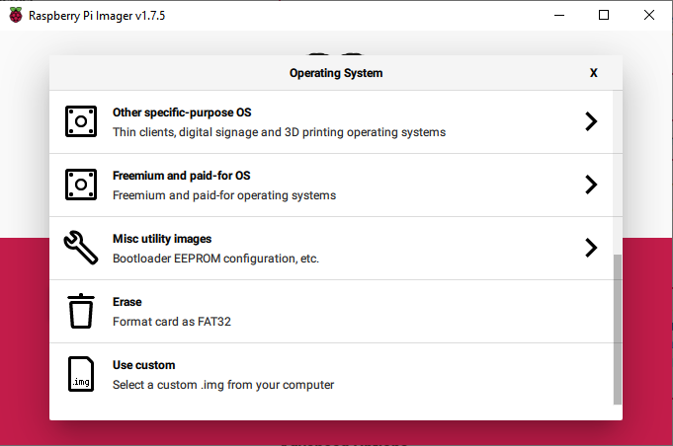

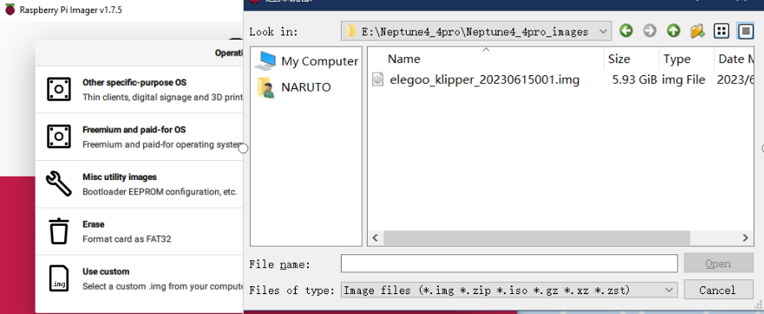

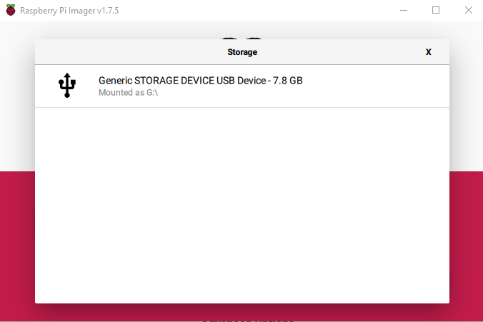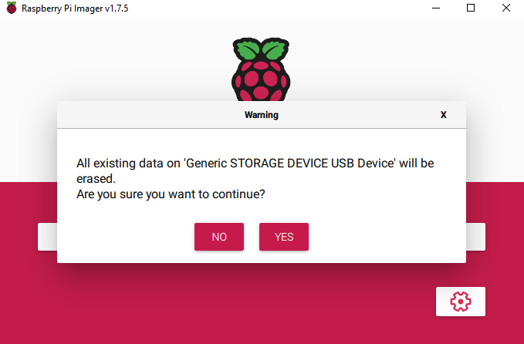

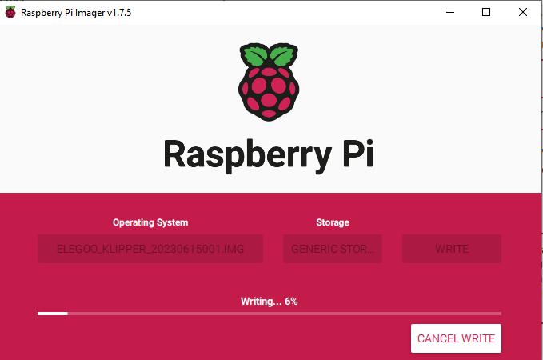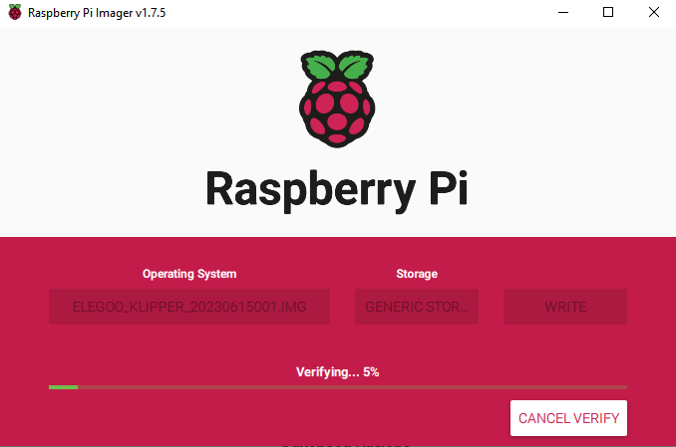

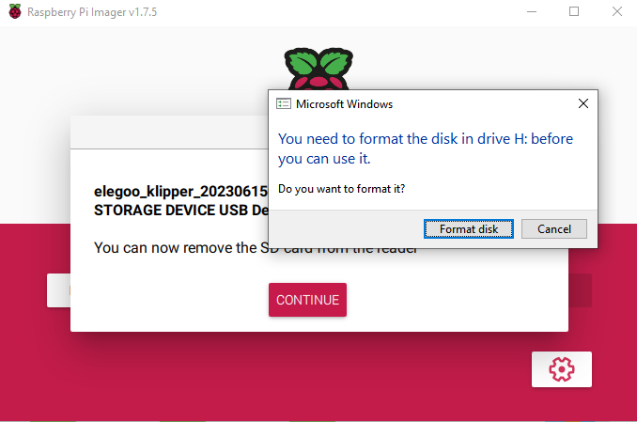

**2.Re-update the repair package for the corresponding model.**

① Reinstall the EMMC module on the Neptune4/4Pro machine's motherboard.

②Follow the firmware update instructions to update the firmware package for the corresponding model.

**NOTE：**

If using Raspberry Pi Imager on Windows 10 with controlled folder access enabled, you will need to explicitly allow Raspberry Pi Imager permission to write the SD card. If this is not done, the imaging process will fail with a "failed to write" error.